Teacher Guide – Drama Familiar: Post-Thanksgiving Skit

Images for Your Skit
- Cocina destruida
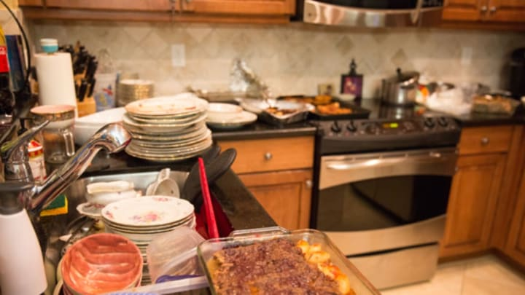
- Refrigerador lleno
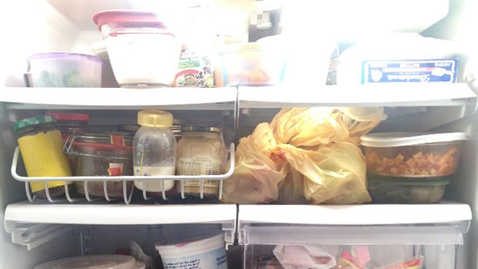
- Gente dormida

- Perro esperando comida
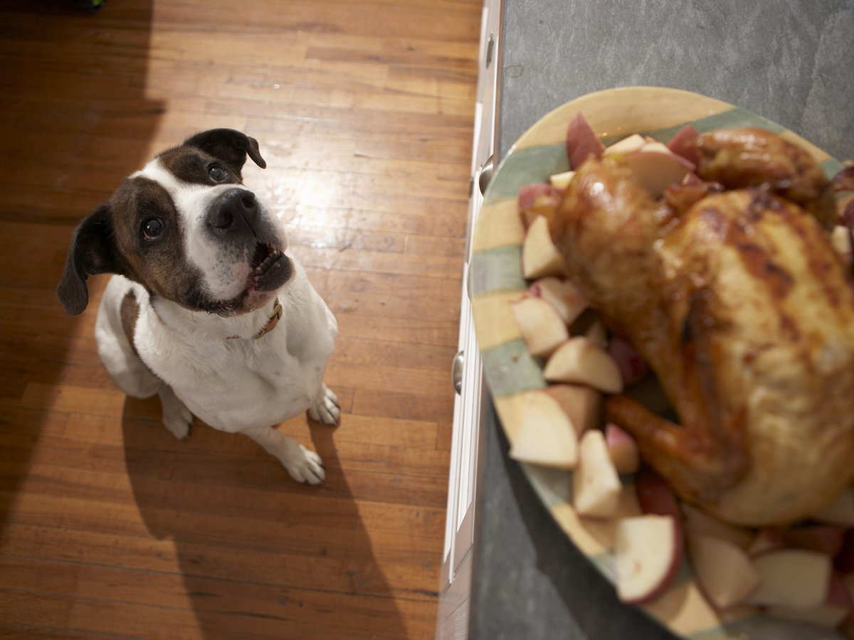

- Compradores agotados del Black Friday

- Sala hecha un desastre


ACTIVITY OVERVIEW
Students work in groups to create a 1–2 minute telenovela-style skit based on a post-Thanksgiving image. The goal is to use the preterite and imperfect tenses in context while engaging in dramatic, humorous storytelling.
MATERIALS
• Projected Post-Thanksgiving images (kitchen disaster, fridge of leftovers, people asleep, dog waiting for food, exhausted shoppers, messy living room)
• Student groups of 3–4
LEARNING GOALS
Students will:
• Use the imperfect to describe ongoing actions and background situations.
• Use the preterite to express completed actions and dramatic events.
• Produce spontaneous dialogue in Spanish using Thanksgiving-related vocabulary.
• Perform exaggerated, dramatic interactions in the style of a telenovela.
STEP-BY-STEP DIRECTIONS
1. Assign Images
Project all six images. Assign one to each group or allow groups to choose.
2. Explain Expectations
Tell students: “Your skit must be a dramatic family scene explaining what happened after Thanksgiving. You must use both preterite and imperfect.”
3. Required Interactions (All MUST appear)
• A confrontation
Example: “Tú sabías la verdad (imperfect) y no dijiste nada (preterite).”
• A confession
Example: “Yo trataba de ayudar (imperfect), pero tiré el puré (preterite).”
• A dramatic interruption
Example: “Todos limpiaban (imperfect) cuando entró la abuela (preterite).”
• A shocking revelation
Example: “Todos creían (imperfect) que el pavo estaba seguro, pero el perro se lo comió (preterite).”
• A closing telenovela line
Example: “Nuestra familia parecía perfecta (imperfect)… hasta que tú llegaste (preterite).”
4. Planning Time
Give students 4–6 minutes to prepare. They may write notes but should not read during the performance. Encourage exaggerated acting, strong emotions, and dramatic reactions.
5. Performances
Groups perform for 1–2 minutes. Encourage the class to react as a live telenovela audience (gasps, applause, dramatic reactions).
SCORING RUBRIC (20 Points)
• Use of Preterite & Imperfect – 6 pts Accurate, meaningful use of both tenses.
• Drama & Creativity – 4 pts Strong emotional acting, exaggerated tone.
• Vocabulary Use – 4 pts Uses Thanksgiving and household vocabulary.
• Required Interactions – 4 pts All five dramatic elements included.
• Pronunciation & Fluency – 2 pts Speaks clearly and stays in Spanish.

TIP
Allow bonus points for:
• Most dramatic moment
• Best shocking revelation
• Best use of imperfect

